**How to Access**

1. [https://www.census.gov](https://www.census.gov/)
2. Topics>Education> Education Attainment>Education Attainment in the United States:2017>Table 1. Education Attainment of the Population 18 years and Over, by Age, Sex, Race, and Hispanic Origin: 2017> All Races
3. No registration needed. Document was opened in excel. Deleted both genders and male to focus on female data. Reformatted table to take unnecessary spacing and imported to R from my computer using an excel document.

**List of Variables in the Dataset**

[1] "Age" "Total"

[3] "None" "1st - 4th grade"

[5] "5th - 6th grade" "7th - 8th grade"

[7] "9th grade" "10th grade"

[9] "11th grade2" "High school graduate"

[11] "Some college, no degree" "Associate's degree, occupational"

[13] "Associate's degree, academic" "Bachelor's degree"

[15] "Master's degree" "Professional degree"

[17] "Doctoral degree"

**structure of the data**

* Except age that is character, the rest of them are numeric.
* > str(Education_table)
* Classes ‘tbl_df’, ‘tbl’ and 'data.frame': 14 obs. of 17 variables:
* $ Age : chr ".18 years and over" "..18 to 24 years" ".25 years and over" "..25 to 29 years" ...
* $ Total : num 127155 14559 112597 11335 10795 ...
* $ None : num 410 29 380 5 22 33 28 25 36 41 ...
* $ 1st - 4th grade : num 761 24 737 29 28 35 43 56 57 75 ...
* $ 5th - 6th grade : num 1575 27 1548 37 94 ...
* $ 7th - 8th grade : num 1800 59 1740 82 129 118 145 135 117 126 ...
* $ 9th grade : num 1746 120 1626 110 157 ...
* $ 10th grade : num 2056 271 1785 161 110 ...
* $ 11th grade2 : num 4923 1536 3388 323 261 ...
* $ High school graduate : num 35010 3794 31216 2678 2359 ...
* $ Some college, no degree : num 24247 5721 18525 2126 1860 ...
* $ Associate's degree, occupational: num 5399 364 5035 492 481 ...
* $ Associate's degree, academic : num 8278 654 7624 832 734 ...
* $ Bachelor's degree : num 26145 1788 24357 3264 2864 ...
* $ Master's degree : num 11680 137 11543 969 1294 ...
* $ Professional degree : num 1426 19 1407 110 167 ...
* $ Doctoral degree : num 1700 16 1685 116 235 ...

**Mean of Five Variables**

* > #mean:
* > mean(Education_table$`Doctoral degree`)
* [1] 363.1429
* > mean(Education_table$`Master's degree`)
* [1] 2493
* > mean(Education_table$`Bachelor's degree`)
* [1] 5474.714
* > mean(Education_table$`Some college, no degree`)
* [1] 4787
* > mean(Education_table$`High school graduate`)
* [1] 7231

**Median of Five Variables**

* > #median:
* > median(Education_table$`Doctoral degree`)
* [1] 155
* > median(Education_table$`Master's degree`)
* [1] 1030.5
* > median(Education_table$`Bachelor's degree`)
* [1] 2353.5
* > median(Education_table$`Some college, no degree`)
* [1] 1792
* > median(Education_table$`High school graduate`)
* [1] 2897

**Mode of Five Variables**

* #mode:
* > one<-table(as.vector(Education_table$`Doctoral degree`))
* > names(one[one==max(one)])
* [1] "16" "79" "108" "116" "117" "137" "140" "170" "189" "192" "200" "235" "1685" "1700"
* > two<-table(as.vector(Education_table$`Master's degree`))
* > names(two[two==max(two)])
* [1] "137" "641" "660" "895" "969" "971" "1003" "1058" "1233" "1294" "1315" "1503"
* [13] "11543" "11680"
* > three<-table(as.vector(Education_table$`Bachelor's degree`))
* > names(three[three==max(three)])
* [1] "1128" "1468" "1603" "1788" "1954" "2231" "2251" "2456" "2487" "2650" "2864" "3264"
* [13] "24357" "26145"
* > four<-table(as.vector(Education_table$`Some college, no degree`))
* > names(four[four==max(four)])
* [1] "1788"
* > five<-table(as.vector(Education_table$`High school graduate`))
* > names(five[five==max(five)])
* [1] "2137" "2213" "2263" "2359" "2646" "2678" "2719" "3075" "3114" "3477" "3794" "4533"
* [13] "31216" "35010"

**Choose one variable**

#create a subset:

* > new<-Education_table[(1:14),(15:15)]

**Variance**

var(new)

* Master's degree
* Master's degree 15039152

**Range**

* #range:
* > max(new)-min(new)
* [1] 11543

**Standard Deviation**

* #standard deviation:
* > sd(new$`Master's degree`)
* [1] 3878.035

**Histogram**

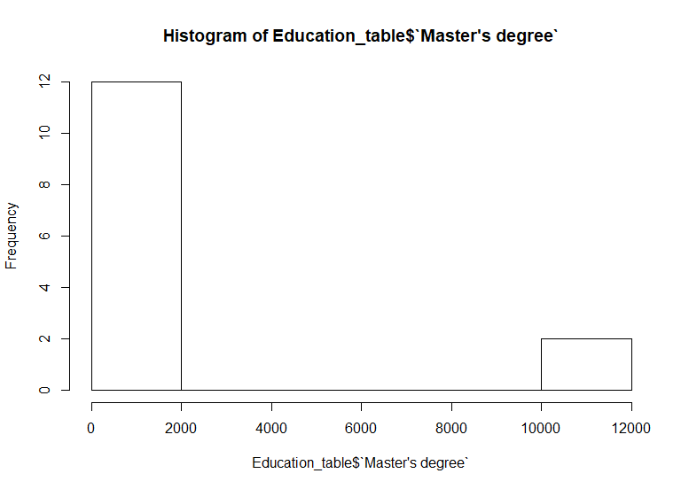

**Box-Plot**

